RODE RECYCLING DAY
on Saturday 30.9.2023 10am-3pm

ELECTRICAL WASTE, SCRAP METAL AND LARGE WASTE ITEMS WILL BE COLLECTED AT TWO COLLECTION POINTS IN KRUUNUVUORENRANTA. This waste collection is only for residents using the pipeline-based waste collection system. Please present your RODE-key at the collection point.

The collection points are located on the map:

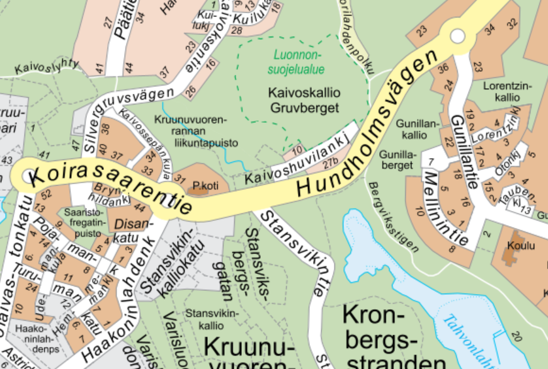

1. Collection point Haakoninlahti is located at the south end of Saaristofregatti’s park, between Pojamankatu 5 and 9.
2. Collection point Gunillankallio is located at the beginning of Mellinintie.
YOU CAN BRING:
LARGE MIXED WASTE:
carpets, mattresses, buckets, folders, furniture etc.
ELECTRICAL AND ELECTRONIC WASTE:
television, home appliance, mobile phone, computer, small appliances, power tools, batteries and bulbs etc.
SCRAP METAL:
bicycle, prams, grills, pots, tools, metal containers, metal furniture etc.
DO NOT BRING
HAZARDOUS WASTE:
- paints, solvents, liquid/vehicle batteries
to HSY hazardous waste container
- waste containing asbestos
to HSY Sortti station (Ämmässuontie 8, 02820 Espoo)
- pressure treated timber
to HSY Sortti station
- medicines, syringes to the Pharmacy
- explosives or guns to the Police
- car tyres: check www.rengaskierratys.com/en

